# INTRODUCTION

Power BI lets you easily connect to your data sources, visualize and discover what’s important, and share that with anyone or everyone you want

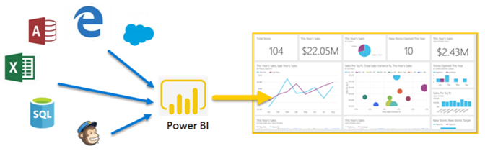

Power BI consists of:

* A Windows desktop application called **Power BI Desktop.**
* An online SaaS service called the **Power BI service / Power BI Online.**
* **Power BI mobile** apps for Windows, iOS, and Android devices.

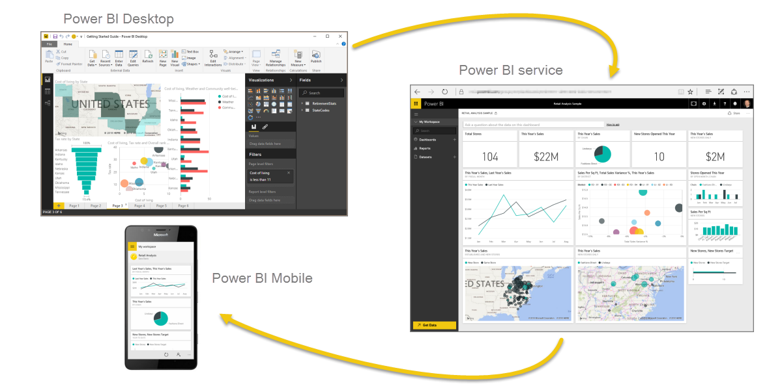

These three elements—Power BI Desktop, the service, and the mobile apps—are designed to let people create, share, and consume business insights in the way that serves them, or their role, most effectively.

A common flow of work in Power BI begins by connecting to data sources and building a report in Power BI Desktop. You then publish that report from Power BI Desktop to the Power BI service, and share it so end users in the Power BI service and mobile devices can view and interact with the report. This workflow is common, and shows how the three main Power BI elements complement one another.

But what if you're not ready to move to the cloud, and want to keep your reports behind a corporate firewall then we can use Power BI Report Server.

**Power BI Report Server** is a solution that you deploy behind your firewall and then deliver your reports to the right users in different ways, whether that’s viewing them in a web browser, on a mobile device, or as an email. And because Power BI Report Server is compatible with Power BI in the cloud, you can move to the cloud when you're ready.

# POWER BI CONTENT

Power BI Desktop is a local application and can only be installed on windows OS. Power BI Service is cloud based application (SaaS) and is OS independent as it will be accessed via a browser over internet.

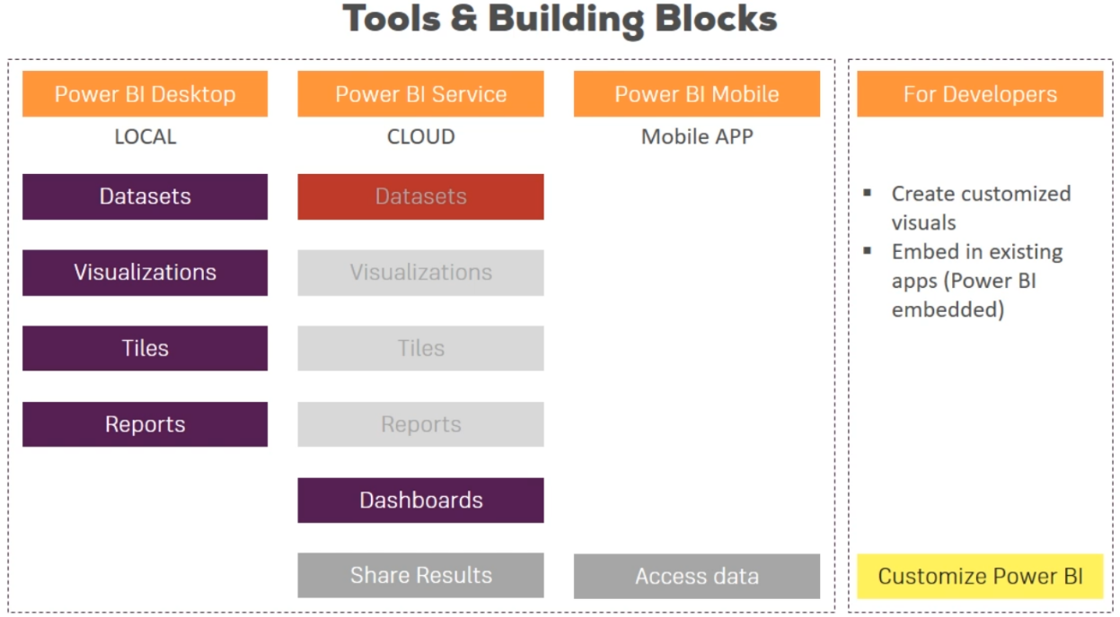

For a Power BI consumer, the five building blocks are: visualizations, dashboards, reports, apps, and datasets. These are sometimes referred to as **Power BI content.** Content exists in workspaces

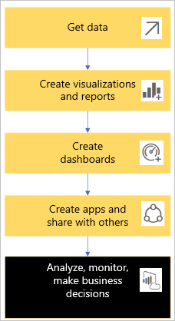

## DATASETS

A dataset is a collection of data (or container of data) that designers import or connect to and then use to build reports and dashboards.

Each dataset represents a single source of data. For example, the source could be an Excel workbook on OneDrive, an on-premises SQL Server Analysis Services tabular dataset, or a Salesforce dataset.

When a designer shares an app with you, you can see which datasets the designer included with the app.

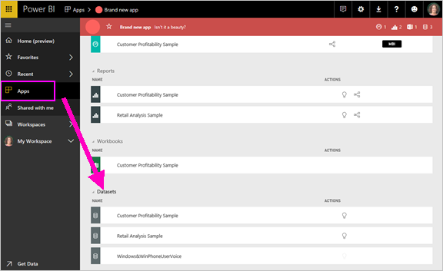

Designers can use datasets from other workspaces to create content (reports, dashboards) in their workspace. Power BI shows these datasets using the referenced dataset icon:



In power BI desktop we can connect to data source and load the data to data model or we can create our own dataset(s) (combine multiple data sources or edit imported single dataset).

Where as in Power BI Service, we cannot create data source. We can only connect to existing datasets.

## VISUALIZATION

A visualization (or visual), is a type of chart built by Power BI designers. The visuals display the data from reports and datasets. Typically, designers build the visuals in Power BI Desktop.

Visualizations (also known as visuals) display insights that Power BI discovered in the data. Visualizations make it easier to interpret the insight, because your brain can comprehend a picture faster than a spreadsheet of numbers.

Just some of the visualizations you'll come across in Power BI are: waterfall, ribbon, treemap, pie, funnel, card, scatter, and gauge:

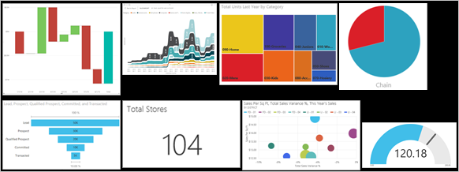

## REPORTS

A Power BI report is a multi-perspective view into a dataset, with visuals that represent different findings and insights from that dataset. A report can have a single visual or pages full of visuals.

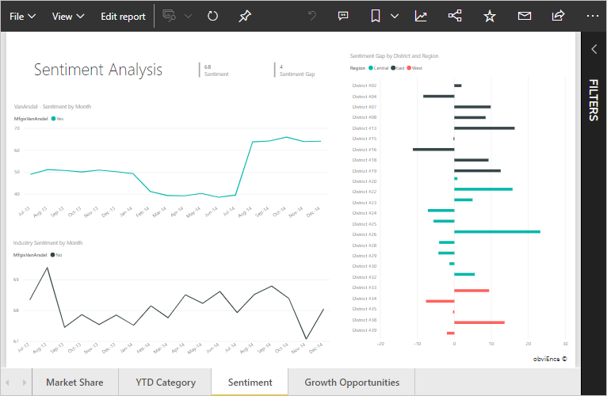

This report has four pages (or tabs) and you're currently viewing the **Sentiment** page. On this page are five different visuals and a page title.

Power BI bases a report on a single dataset. Report *designers* create the visuals in a report that represent a nugget of information. The visuals aren't static. They update as the underlying data changes. You can interact with the visuals and filters as you dig into the data to discover insights and look for answers. Like a dashboard, a report is highly interactive and highly customizable.

One report:

* Can be associate it with multiple dashboards (tiles pinned from that one report can appear on multiple dashboards).
* Can be created using data from only one dataset.
* Can be part of multiple apps.

## DASHBOARDS

A dashboard represents a customized view of some subset of the underlying dataset(s). Designers build dashboards and share them with consumers; either individually or as part of an app. A dashboard is a single canvas that has tiles, graphics, and text.

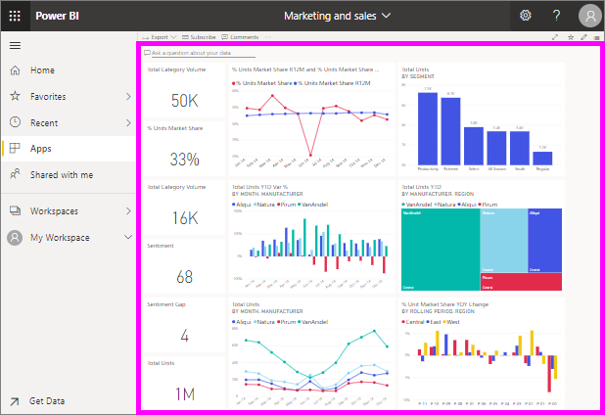

Some purposes for dashboards:

* To see, in one glance, all the info needed to make decisions
* To monitor the most-important info about your business
* To ensure all colleagues are on the same page; viewing and using the same info
* To monitor the health of a business or product or business unit or marketing campaign, and so on
* To create a personalized view of a larger dashboard -- all the metrics that matter to you.

ONE dashboard:

* Can display visualizations from many different datasets
* Can display visualizations from many different reports
* Can display visualizations pinned from other tools (for example, excel)

The visualizations on a dashboard come from reports and each report is based on one dataset.

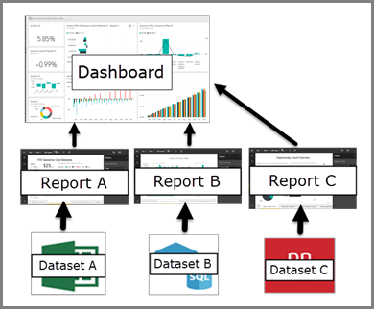

## APPS

These are collections of dashboards and reports organize related content together into a single package. Power BI designers build them and share them with individuals, groups, an entire organization, or the public.

An app is a way for designers to bundle and share related dashboards and reports together. Consumers receive some apps automatically but can go search for other apps created by colleagues or by the community. For example, external services you may already use, like Google Analytics and Microsoft Dynamics CRM, offer Power BI apps.

You can get apps in a few different ways:

* The app designer can install the app automatically in your Power BI account.
* The app designer can send you a direct link to an app.
* You can search for it in Microsoft AppSource, where you see all the apps that you can use.

Using Power BI Service, we can share and collaborate with other colleagues in the organization.

## TILE

The visualizations you see on the dashboard are called tiles and are pinned to the dashboard by report designers. In most cases, selecting a tile takes you to the report page where the visualization was created.

A tile can be created from a report, dataset, dashboard, the Q&A question box, Excel, SQL Server Reporting Services (SSRS), and more. This screenshot shows many different tiles pinned to a dashboard.

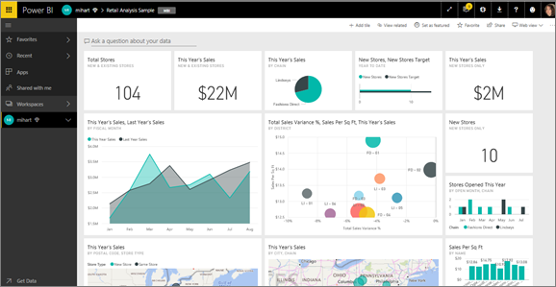

Besides tiles pinned from reports, designers can add standalone tiles directly on the dashboard using Add tile. Standalone tiles include: text boxes, images, videos, streaming data, and web content.

## POWER BI DESKTOP vs POWER BI SERVICE

In a Venn diagram comparing Power BI Desktop and the Power BI service, the area in the middle would show how the two overlap. Some tasks you can do in either Power BI Desktop or the service. But on the two sides of the Venn diagram, the application and the service each have unique features.

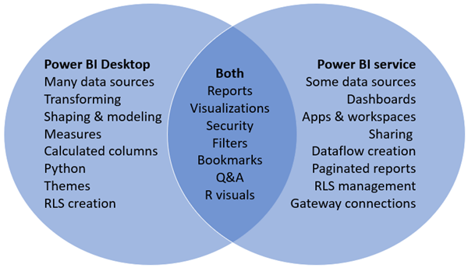

## DASHBOARDS VERSUS REPORTS

[Dashboards](https://docs.microsoft.com/en-us/power-bi/consumer/end-user-dashboards) are often confused with reports since they're also canvases filled with visuals. But there are some major differences.

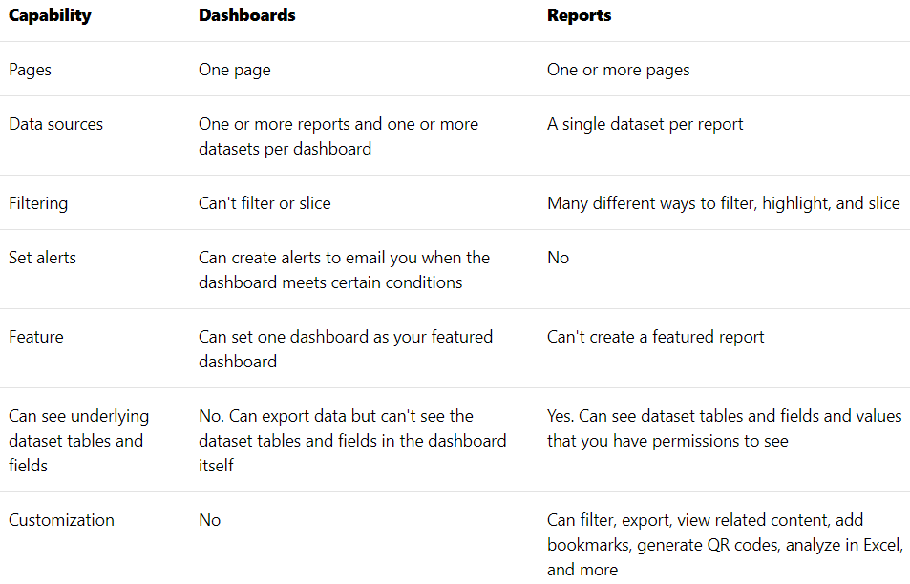

# POWER BI DESKTOP WORKFLOW

Below is a typical Power Bi desktop workflow:

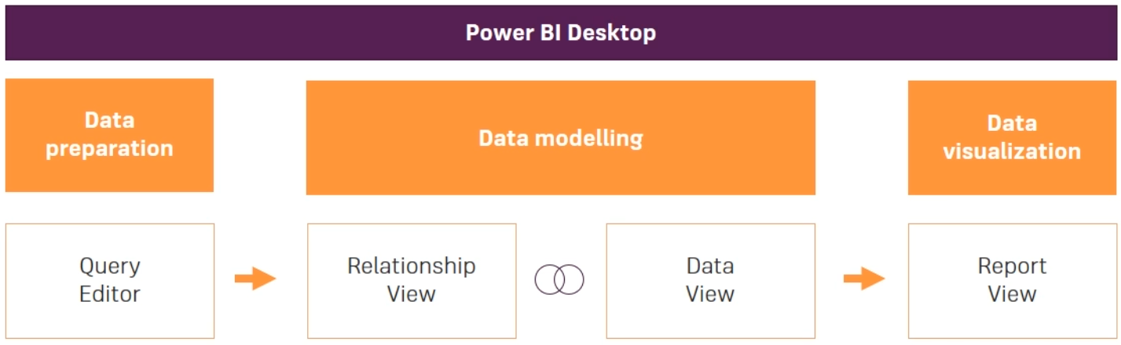

# REPORT EDITOR

In both the application i.e. BI Desktop and BI Service, you can build and edit *reports*. A report can have one or many pages, with visuals and collections of visuals. You can add bookmarks, buttons, filters, and drillthrough, to enhance navigation in your reports.

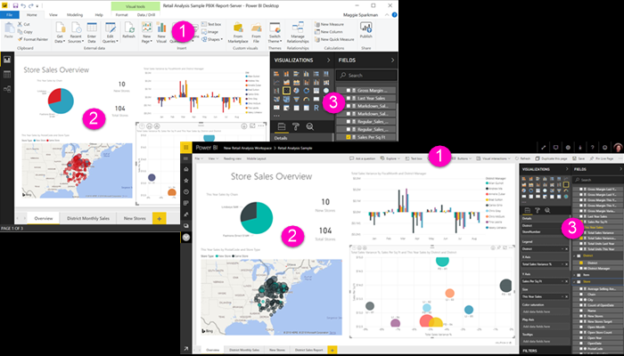

The report editors in Power BI Desktop and in the service are similar. They're made up of three sections:

1. The top navigation bars (ribbons), different in Power BI Desktop and the service.
2. The report canvas.
3. The Fields, Visualizations, and Filters panes.

# QUERY EDITOR

To go to query editor, click on below options on the BI interface.

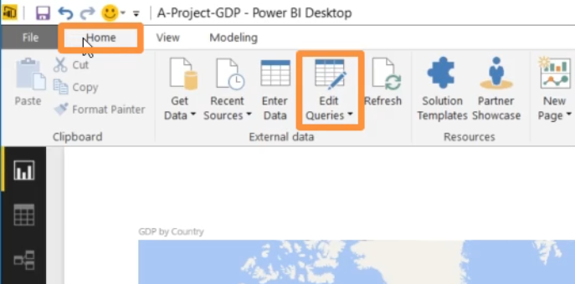

This will open another window as shown below where we can work with the imported data from the data source.

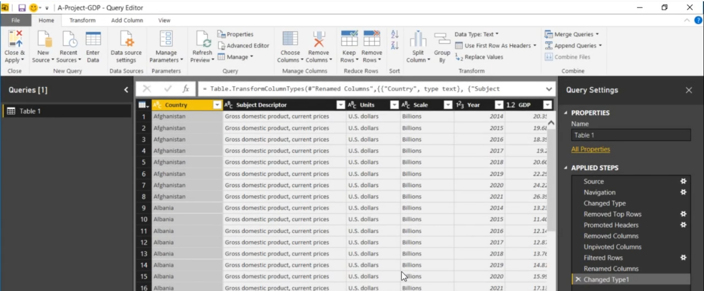

## QUERIES

Below figure shows the query section. Here we can see all the data sources we are connected to and all the objects available in the connected datasources.

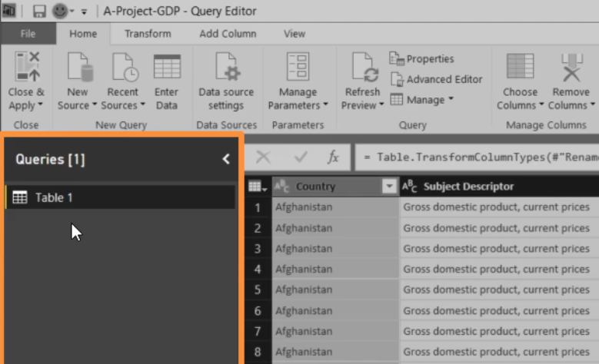

## QUERY SETTINGS

Below figure shows the Query settings section,

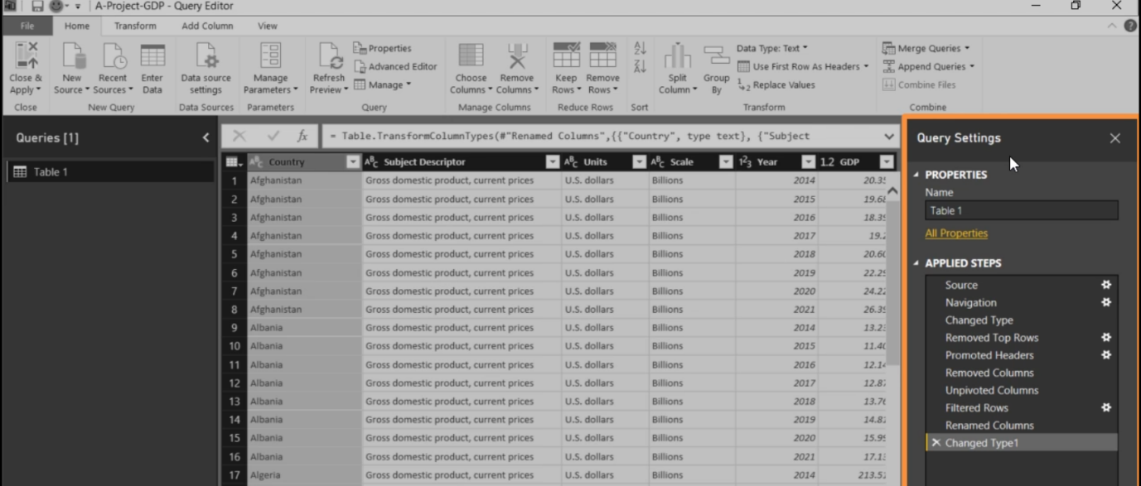

Here we can mainly do two things

* Edit the query name
* We can undo applied steps

## FORMULA BAR

This formula bar shows formulas in M Language where as the Data Model uses DAX language

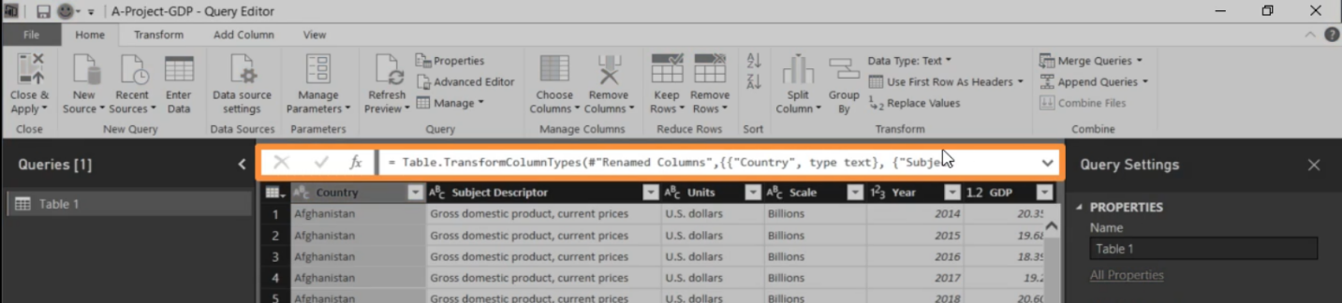

# COLLABORATING IN THE POWER BI SERVICE

After you've created your reports, you can save them to a **workspace** in the Power BI service, where you and your colleagues collaborate. You build dashboards on top of those reports. Then you share those dashboards and reports with report consumers inside and outside your organization. Your report consumers view them in the Power BI service in Reading view, not Editing view. They don't have access to all the features available to report creators.

# POWER BI EXTENSION

Below are some important extension files in power BI:

* Power BI file (*.pbix)

# REFERENCES

<https://docs.microsoft.com/en-us/power-bi/consumer/end-user-basic-concepts>